Evidence of building Team Culture:

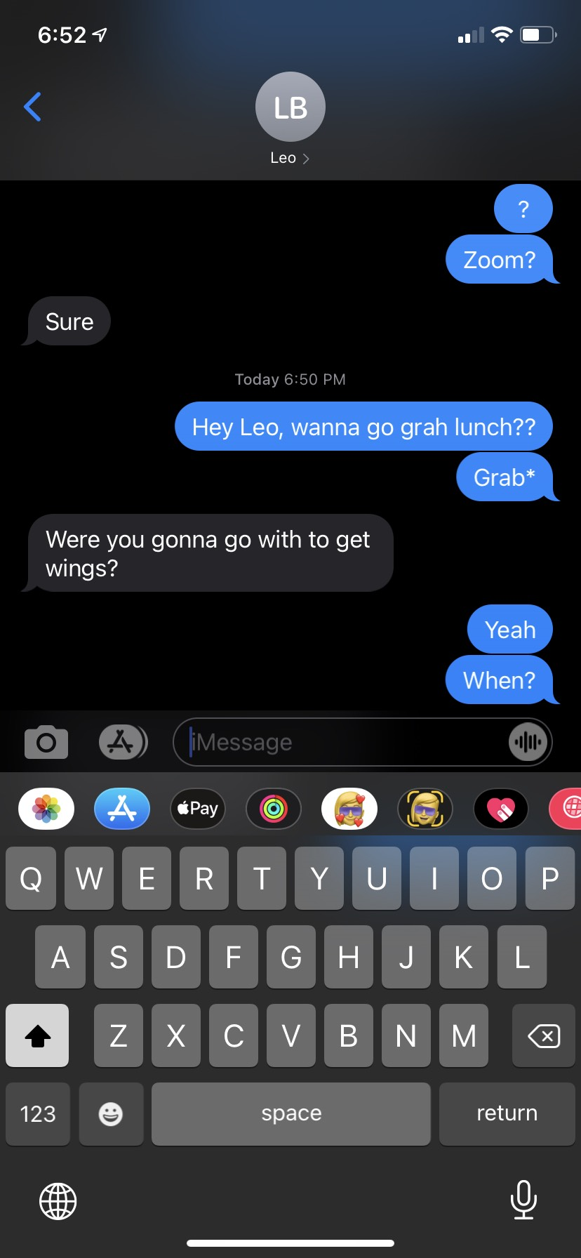

Evidence for Remote Communication:

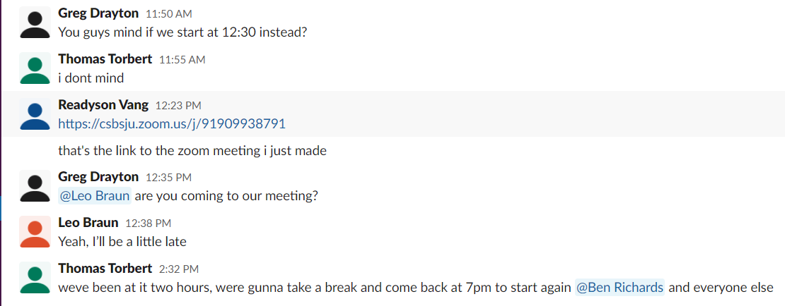

Evidence of Testing:

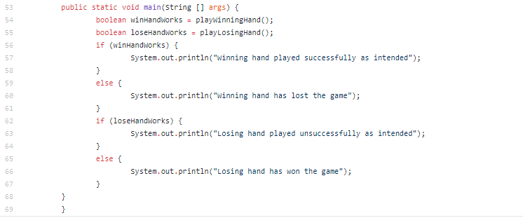

Evidence for design documents:

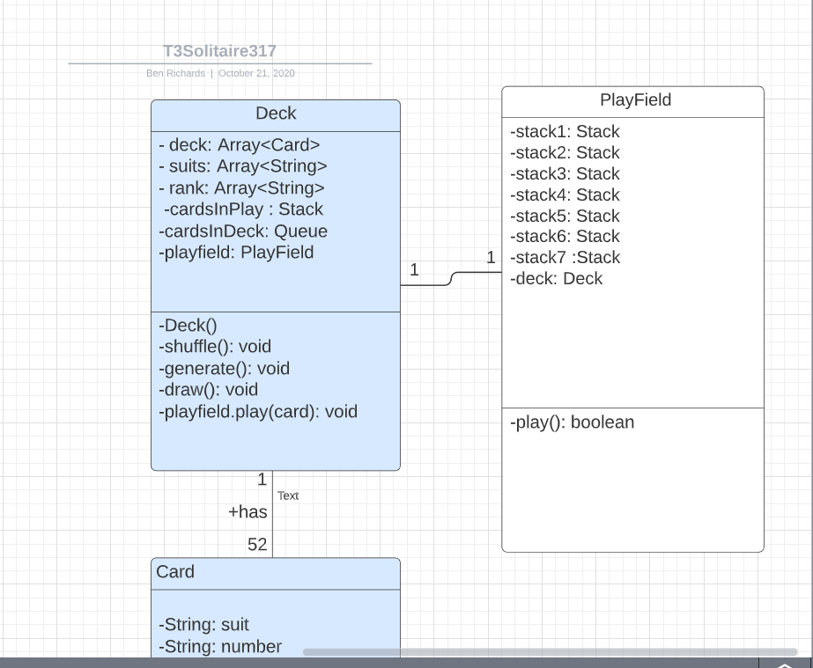

Evidence of User stories:

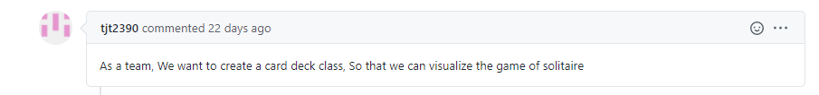

Evidence of Creating issues that describe Devlopment tasks:

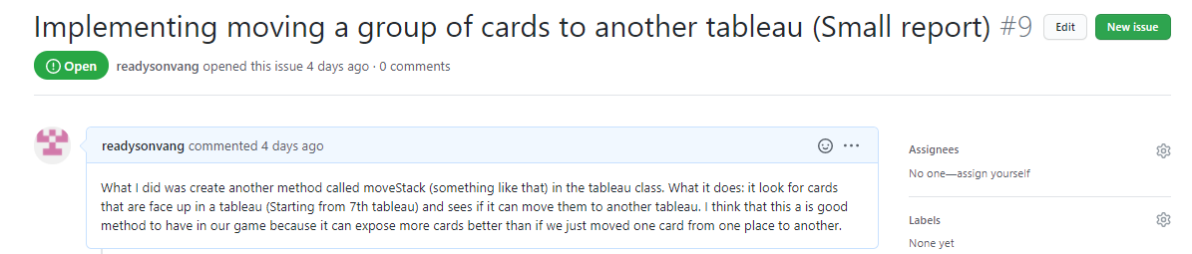

Evidence of creating Code documentation:

